PIZZA SALES SQL QUERIES
- KPI’s

- Total Revenue:
SELECT SUM(total_price) AS Total_Revenue from pizza_sales;

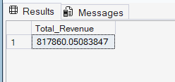

- Average Order Value:
SELECT SUM(total_price)/COUNT(DISTINCT order_id) AS AVG_Order_Value
From pizza_sales

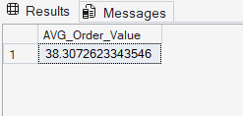

- Total Pizzas Sold:
SELECT SUM(quantity) AS Total_Pizza_Sold from pizza_sales
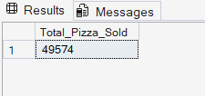
- Total Orders:
SELECT COUNT(DISTINCT order_id) AS Total_Order from pizza_sales
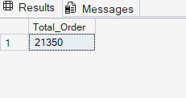
- Average Pizza Per Order:
SELECT CAST(CAST(SUM(quantity) AS DECIMAL(10,2))/
CAST(COUNT(DISTINCT order_id)AS DECIMAL(10,2))
AS DECIMAL(10,2))AS Avg_Pizzas_per_order
from pizza_sales

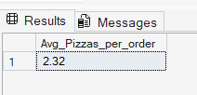

- CHART’S
- Hourly Trend for Total Pizzas Sold:
SELECT DATEPART(HOUR, order_time) AS Order_Hour, SUM(quantity) AS Total_Pizzas_Sold
FROM pizza_sales
GROUP BY DATEPART(HOUR, order_time)
ORDER BY DATEPART(HOUR, order_time)
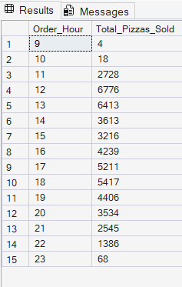

- Weekly Trend for Orders:
SELECT
DATEPART(ISO_WEEK, order_date) AS Week_Number,
Year(order_date) AS Order_Year,
COUNT(DISTINCT order_id) AS Total_Orders
FROM
pizza_sales
GROUP BY
DATEPART(ISO_WEEK ,order_date), YEAR(order_date)
ORDER BY
DATEPART(ISO_WEEK ,order_date), YEAR(order_date)
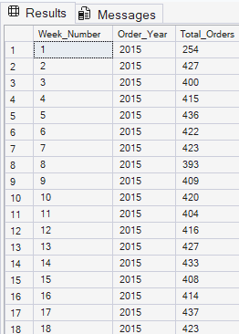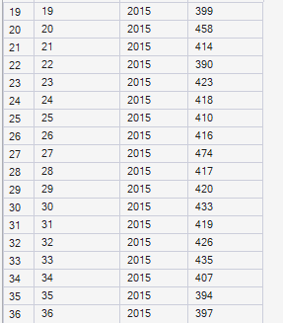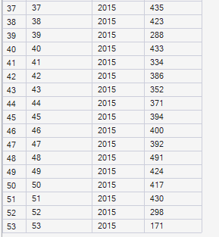

- % of Sales by Pizza Category:
SELECT pizza_category, CAST(SUM(total_price) AS DECIMAL(10,2)) as total_revenue,
CAST(SUM(total_price) * 100 / (SELECT SUM(total_price) from pizza_sales) AS DECIMAL(10,2)) AS PCT
FROM pizza_sales
GROUP BY pizza_category
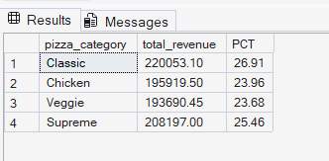

- % of Sales by Pizza Size:
SELECT pizza_size, CAST(SUM(total_price) AS DECIMAL(10,2)) as total_revenue,
CAST(SUM(total_price) * 100 / (SELECT SUM(total_price) from pizza_sales) AS DECIMAL(10,2)) AS PCT
FROM pizza_sales
GROUP BY pizza_size
ORDER BY pizza_size

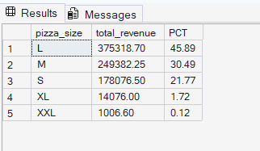

- Total Pizzas Sold by Pizza Category:
SELECT pizza_category, SUM(quantity) as Total_Quantity_Sold
FROM pizza_sales
WHERE MONTH(order_date) = 2
GROUP BY pizza_category
ORDER BY Total_Quantity_Sold DESC
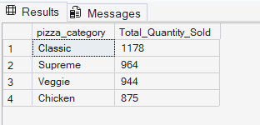

- Top 5 Pizzas by Revenue:
SELECT TOP 5 pizza_name, SUM(total_price) AS Total_Revenue FROM pizza_sales
GROUP BY pizza_name
ORDER BY Total_Revenue DESC
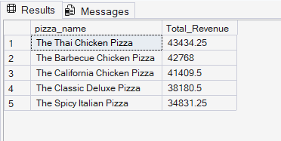

- Bottom 5 Pizzas by Revenue:
SELECT TOP 5 pizza_name, SUM(total_price) AS Total_Revenue FROM pizza_sales
GROUP BY pizza_name
ORDER BY Total_Revenue ASC
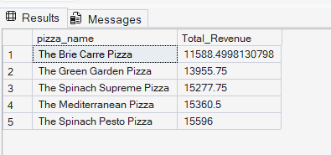

- Top 5 Pizzas by Quantity:
SELECT TOP 5 pizza_name, SUM(quantity) AS Total_Quantity FROM pizza_sales
GROUP BY pizza_name
ORDER BY Total_Quantity DESC

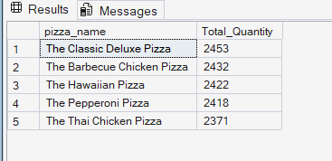

- Bottom 5 Pizzas by Quantity:
SELECT TOP 5 pizza_name, SUM(quantity) AS Total_Quantity FROM pizza_sales
GROUP BY pizza_name
ORDER BY Total_Quantity ASC

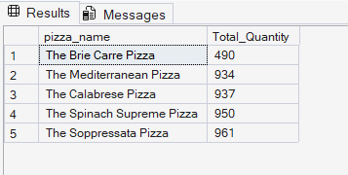

- Top 5 Pizzas by Total Orders:
SELECT Top 5 pizza_name, COUNT(DISTINCT order_id) AS Total_Orders
FROM pizza_sales
GROUP BY pizza_name
ORDER BY Total_Orders DESC
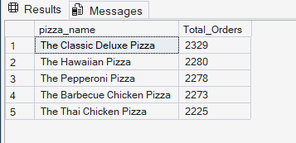

- Bottom 5 Pizzas by Total Orders:
SELECT Top 5 pizza_name, COUNT(DISTINCT order_id) AS Total_Orders
FROM pizza_sales
GROUP BY pizza_name
ORDER BY Total_Orders ASC

